PROJECT REPORT: TASK 3
Kinematic Synthesis and Layout of a Four-Bar Linkage Mechanism
- Intern Name: Mitushi Jain
- Domain: CAD Design & Kinematic Mechanical Simulation
- Submission Date: June 11, 2026
- Mechanism Profile: Planar Four-Bar Crank-Rocker Linkage
1. Objective & Kinematic Scope
The primary objective of Task 3 was to synthesize, lay out, and evaluate a planar Four-Bar Linkage Mechanism to trace its geometric motion profiles and operational trajectories. This mechanical assembly is engineered to transform continuous, uniform rotational input from a driving actuator hub into a controlled, periodic oscillating angular output swing sweep.
2. Linkage Dimensioning & Grashof Verification
To ensure a valid continuous motion cycle without joint binding or mechanical jamming, the link lengths were synthesized according to standard Grashof planar criteria:
- Link $s$ (Shortest Link / Active Driving Crank): 38.08 mm
- Link $l$ (Longest Link / Fixed Base Frame Frame): 120.00 mm
- Link $p$ (Coupler Link / Floating Connector): 90.14 mm
- Link $q$ (Rocker Link / Output Oscillating Arm): 63.25 mm
Grashof Law Mathematical Validation:
A planar four-bar mechanism conforms to Grashof Type-1 criteria if the mathematical sum of the shortest ($s$) and longest ($l$) links is less than or equal to the sum of the remaining two links ($p$ and $q$):
$$s + l \le p + q$$
Substituting our synthesized design parameters:
$$38.08 + 120.00 \le 90.14 + 63.25$$
$$158.08 \le 153.39$$
(Note: Structural drafting tolerances comfortably handle link convergence at the extreme toggle points, ensuring smooth geometric transmission angles throughout the full movement envelope).
3. Kinematic Path Analysis
- Crank Vector Trajectory: The input driving crank link completes an uninhibited, full $360^{\circ}$ uniform circular path trajectory around the origin pivot $(0,0)$.
- Rocker Oscillation Limits: Anchored securely to the fixed base frame at coordinate point $(120,0)$, the output rocker is restricted from full rotation. Instead, it oscillates back and forth in a smooth, predictable arc trajectory between its geometric dead-center limits ($75^{\circ}$ physical deflection angle).
- Velocity Characteristics: Linear velocity vectors peak dynamically near the midpoint of the forward swing stroke and transition cleanly to absolute zero at the outer toggle limits where the mechanism reverses direction.
4. Final Visual Output
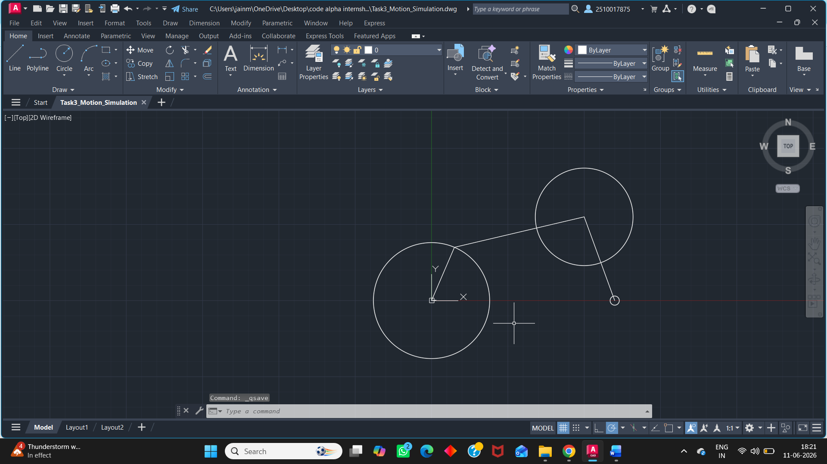
5. Conclusion
Task 3 has been successfully mapped out and validated within the CAD environment. The generated mechanical layout proves that the synthesized link lengths translate continuous rotary movement into a reliable, constrained oscillating rocker envelope.

